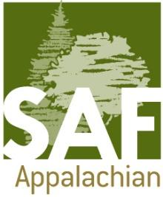
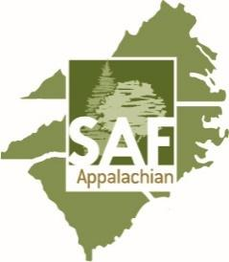

APSAF Social Media Internship 2024
Term: February 1, 2024 – January 31, 2025

Duties:

- ApSAF Social Media Interns are responsible for populating the ApSAF social media pages with content relevant to ApSAF members - particularly the students.
- Each intern is expected to contribute at least three (3) posts every third week. Interns should strive to create posts that encapsulate the life and experiences of a forester, or someone working in a profession (being a student is a profession!) related to forestry.
- One photo each week should be on a Tuesday using our #TreeIDTuesday hashtag. This post will challenge the viewers to guess the tree species and encourage them to interact.
- Good photos are a must; posts can highlight anything related to forestry, including the different professions, forest health issues, forest products, utilization, silviculture, harvesting, effects and impacts of prescribed or wildfire on forests, etc. This venue simply highlights forestry in the ApSAF region (NC, SC, and VA).
- Manage LinkedTree page with updated websites.
- Intern will be responsible for replying to comments, interacting with posts, and creating events.
- Encourage new followers on all platforms.

Benefits:

Student interns will receive a stipend of $500 for the year, free registration to the 2025 ApSAF Winter Meeting, and formal recognition at the 2025 APSAF Winter Meeting. They will be encouraged to include this internship on their CV/Resume. ApSAF will receive exposure through social media activity and increased engagement with our younger group members.

To apply please email this application as a Word document or PDF to: tmarkus@g.clemson.edu

With the subject line APSAF Social Media Application
Application close date: January 5, 2024

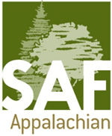
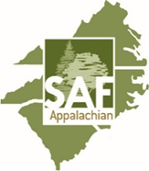
Application

Name: ________________________
State: _________________________
Cell Phone: ____________________
Email: ________________________
Preferred social media for personal use: (Please check all that apply)

- TikTok
- Instagram
- Other: (please list)
- Facebook
- Twitter

__________________________________________________________

Please list your social media handles:

TikTok: ___________________________________________________
Instagram: ________________________________________________
Facebook: ________________________________________________
Twitter: ___________________________________________________
Other: (please list)
_________________________________________________________

Explain how social media influences forestry (200 words or less):

What would you like to get from this internship, and why are you interested? (200 words or less):

Give two examples of what you would post as an APSAF Instagram post: (Picture and caption). Use other sheets if necessary.

